LAB Assignments
Practical 1
Practical Lab Assignment
1. To accept an object mass in kilograms and velocity in meters per second and display its momentum.Momentum is calculated as e=mc2 where m is the mass of the object and c is its velocity.
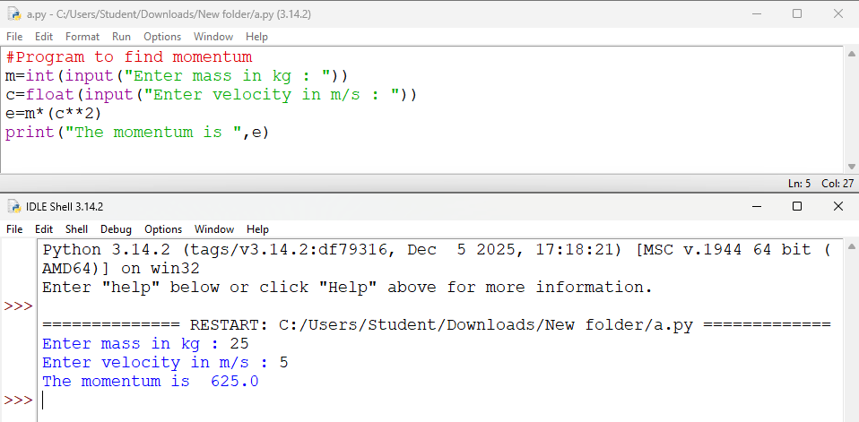
2. Write a Python program for following conditions. If n is single digit print square of it. If n is two digit print square root of it. If n is three digit print cube root of it.
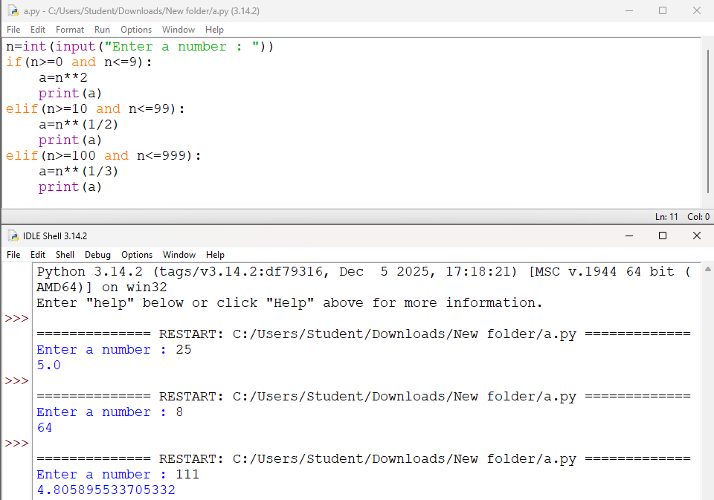
3.Read the birth date and salary in rupees of employees. Perform data transformation for birthdate to age and also salary which is in rupees to salary in dollars using functions.
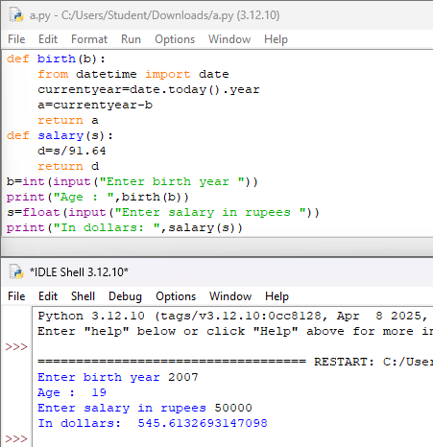
4.Print the reverse number of a given number
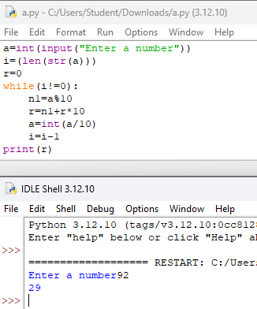
Lab Assignment
1.To accept students five courses marks and compute his/her result. Student is passing if he/she scores marks equal to and above 40 in each course.
If student scores aggregate greater than 75 percentage, then the grade is distinction.
If aggregate is greater than or equal to 60 and less than 75 then the grade if first division.
If aggregate is greater than or equal 50 and less than 60, then the grade is second division.
If aggregate is greater than or equal 40 and less than 50, then the grade is third division.
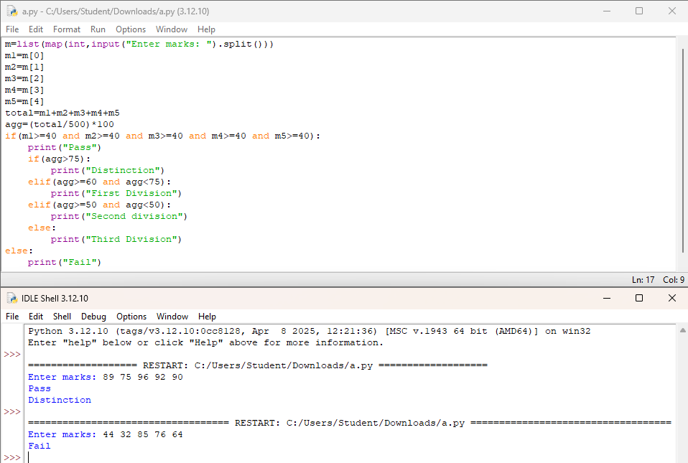

2.Solve the Fibonacci sequence using recursive function in Python.
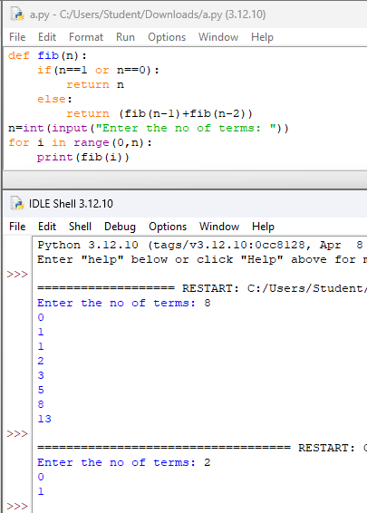
3.Write a Python program to print different patterns.
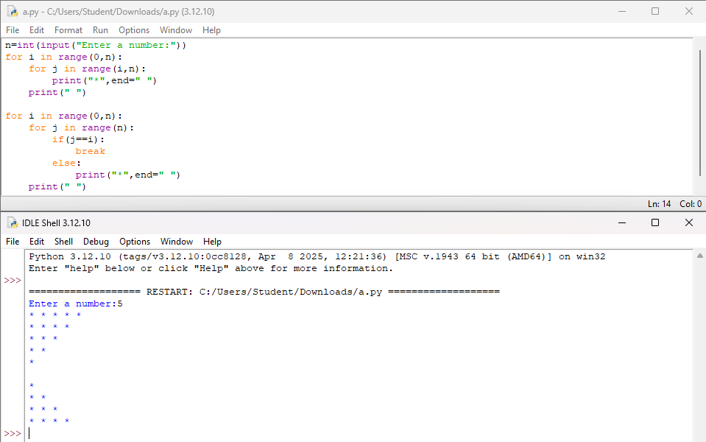
Practical 2
Practical Lab Assignment
1.Perform all List Operations, Dictionary Operations.
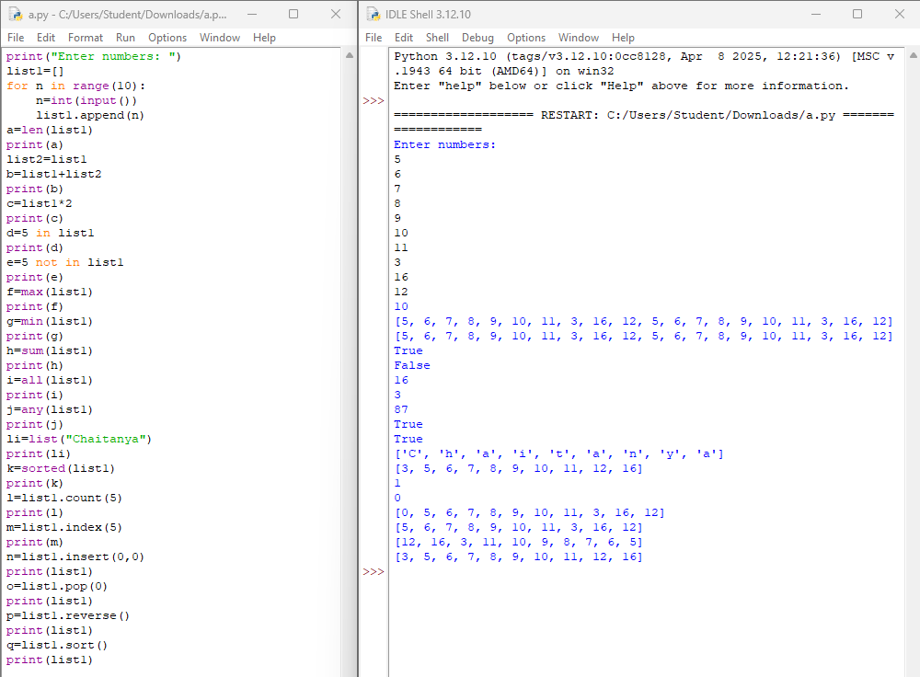
Lab Assignment
1.Select the number from the entered list and find its position in Python (use Linear Search).
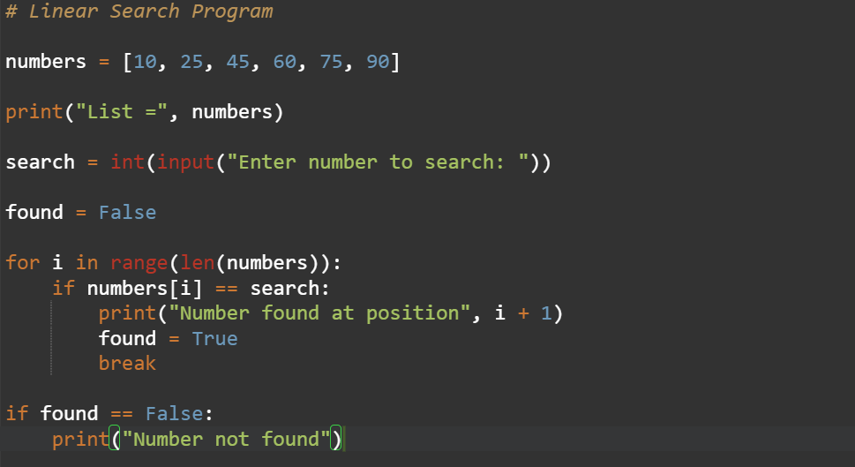
2.Choose cricket team of eleven players find the captain of the team (consider tallest person as a captain) using dictionary.
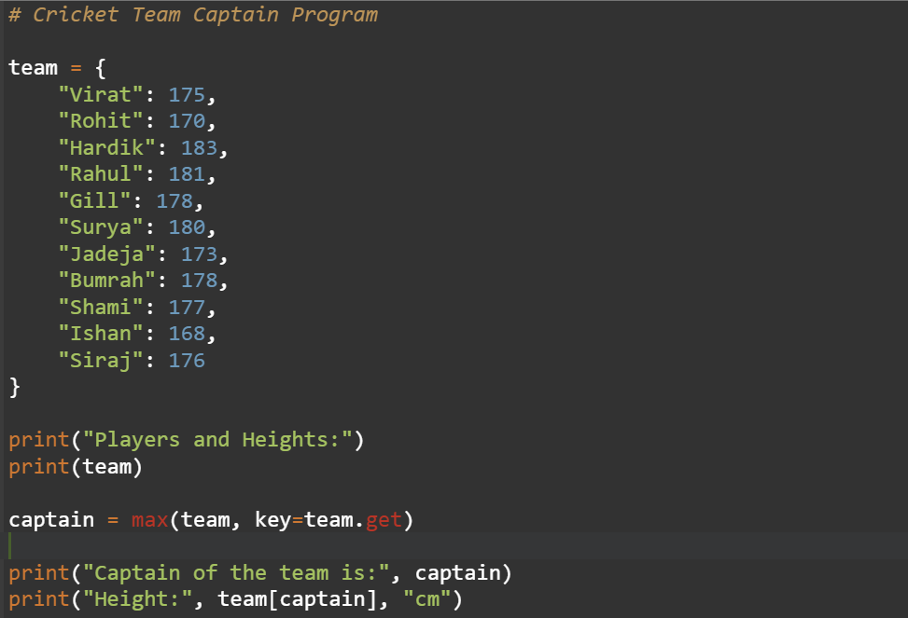
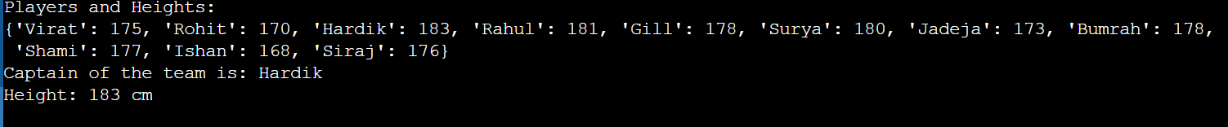
Practical 3
Practical Lab Assignment
1.Perform all the Numpy operations in python.
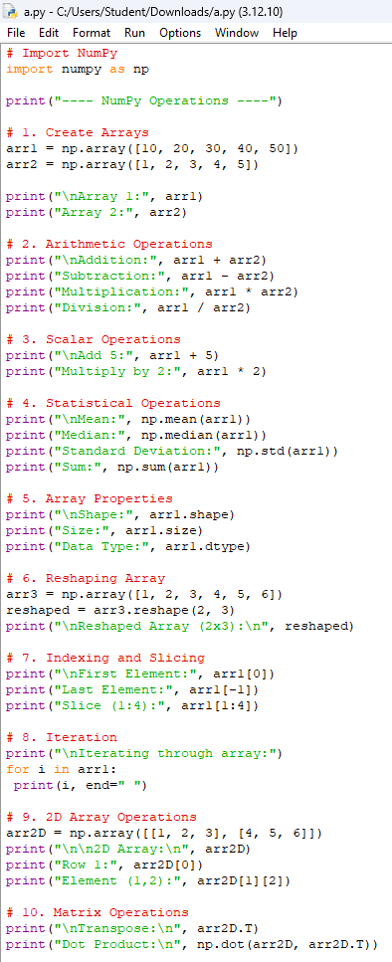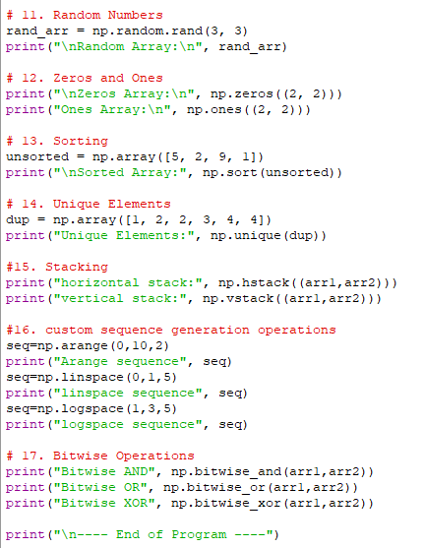
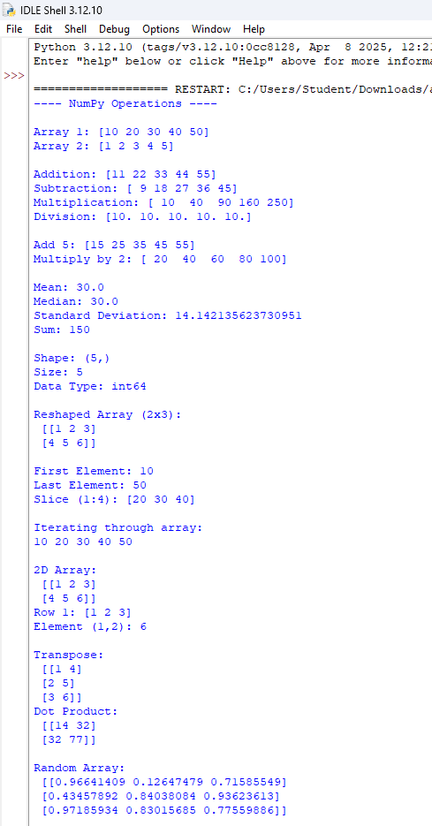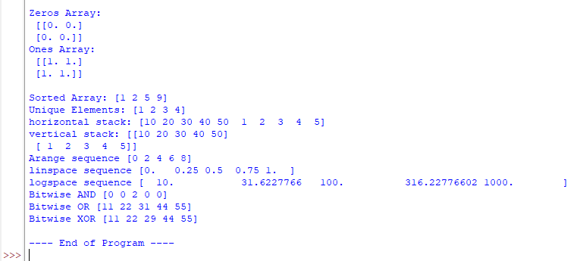
Lab Assignment
1.Prepare/Take dataset for any real life application. Read a dataset into an array. Perform followingoperations on it as:
- Perform all matrix operations
- Horizontal and vertical stacking of Numpy Arrays
- Custom sequence generation
- Arithmetic and Statistical Operations, Mathematical Operations, Bitwise Operators
- Copying and viewing arrays
- Data Stacking, Searching, Sorting, Counting, Broadcasting
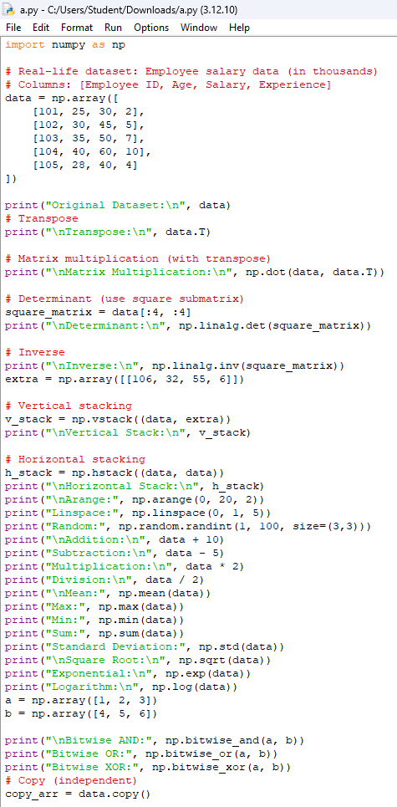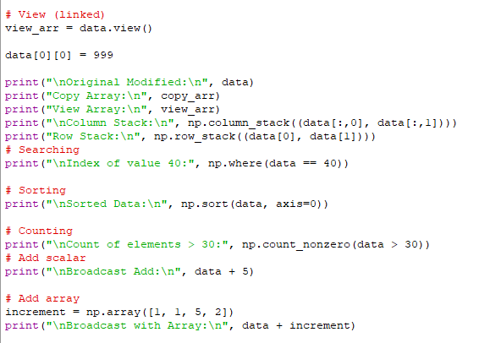
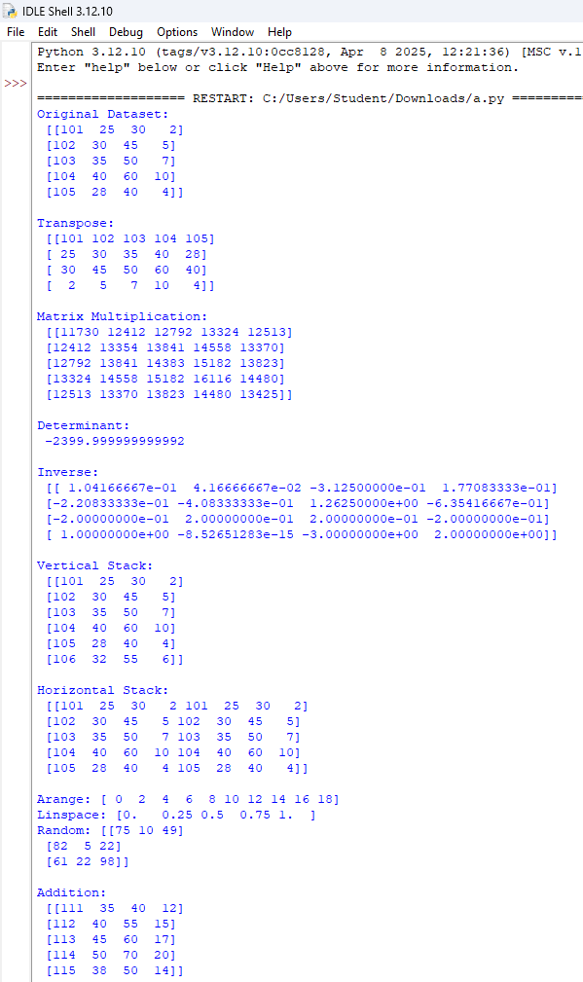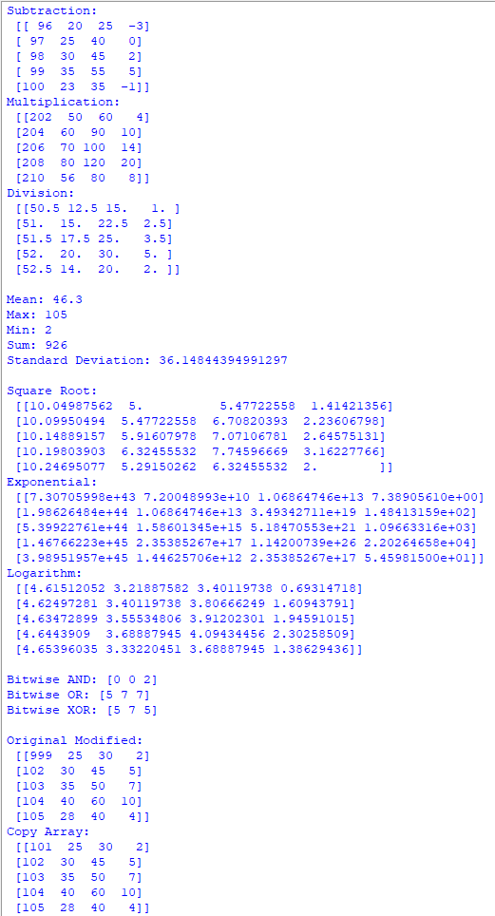
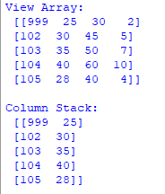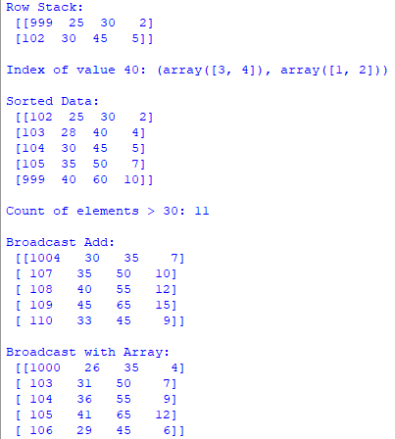

Practical 4
Practical Lab Assignment
1.Perform all the pandas operations in python.
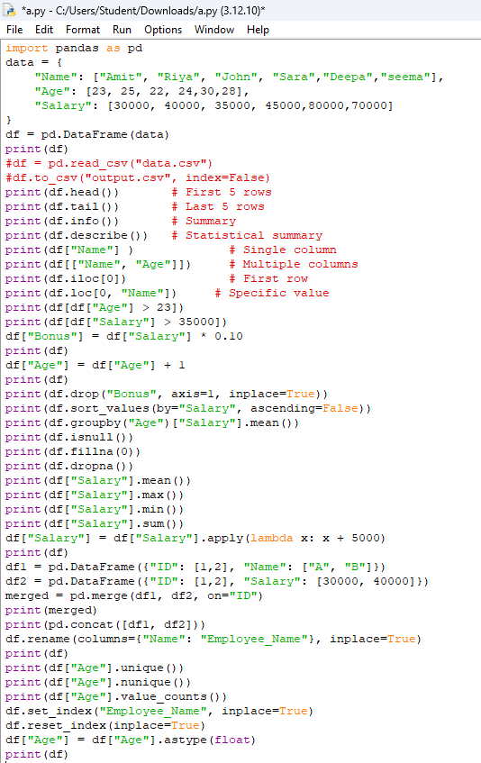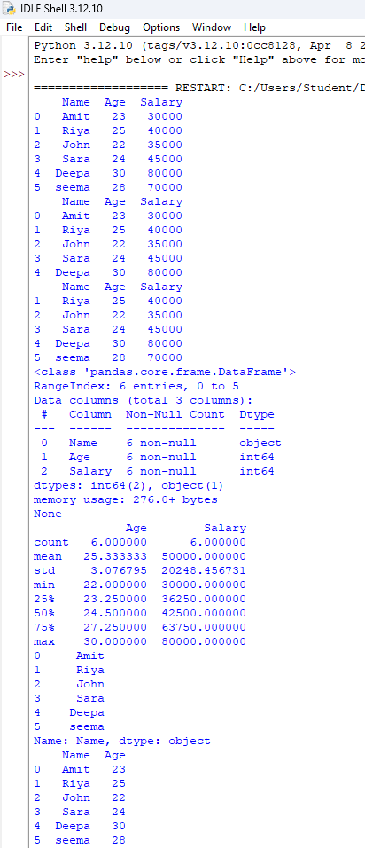
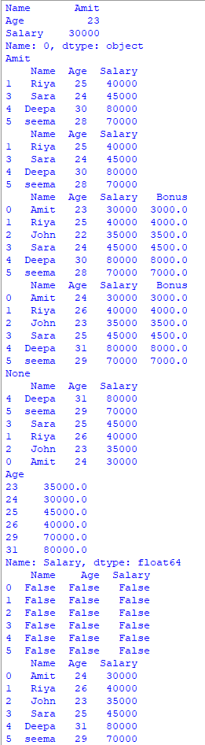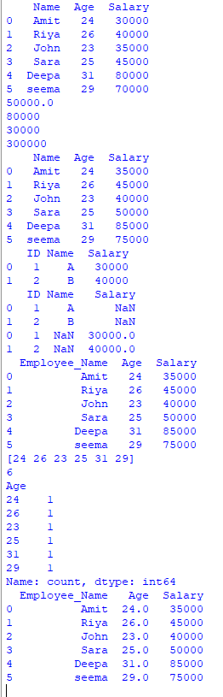
Lab Assignment
1.Read any real life dataset. Store the data into Data Frames. Identify 10 grains
for the given dataset. Implement all 20 grains using Pandas methods. The Sample Grains for Sales
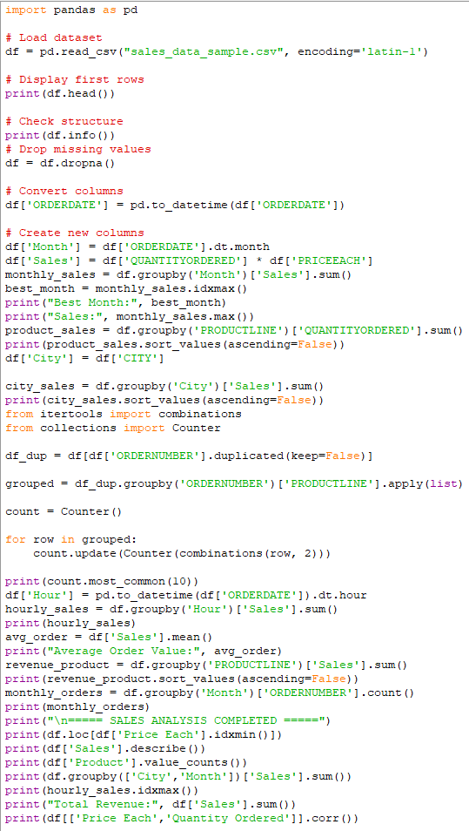
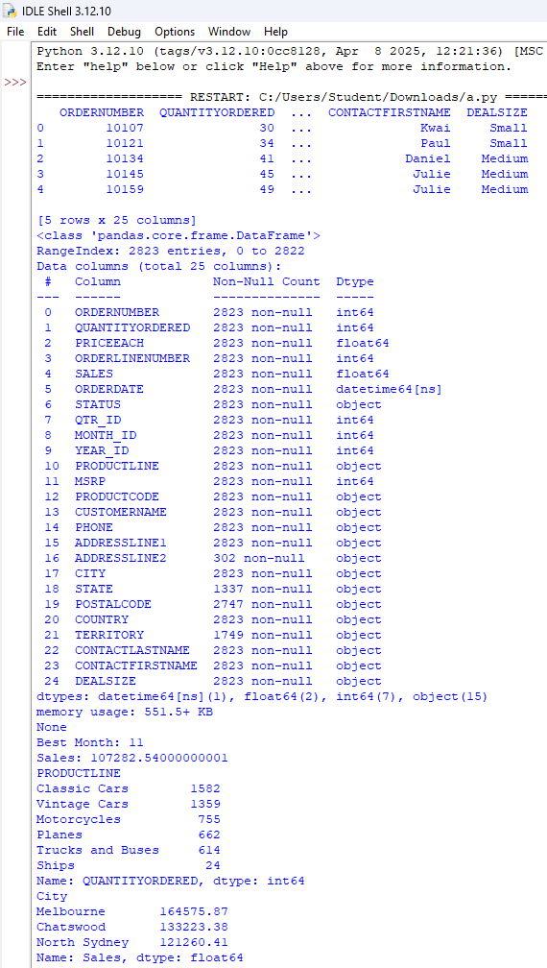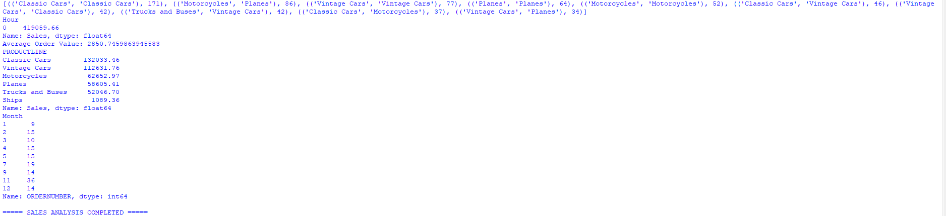

Practical 5
Practical Lab Assignment
1.Install MatPlotLib library. Draw basic graphs for sales dataset using MatPlotLib.
